CSE 581

**Lab 17: Performance tuning with Indexes.**

1. **Create the following table:**

CREATE TABLE TestForIndex

(

TestID INT PRIMARY KEY,

Column1 INT NOT NULL

);

1. **Write a stored procedure that will insert 1 million records into the TestForIndex table. The values[1] for both testId and column1 should start at 0 and increase by 1.**

CREATE PROCEDURE dbo.MyInsertProcedure(@number AS INT)

AS

DECLARE @counter INT

SET @counter = 0;

BEGIN

WHILE (@counter < @number)

BEGIN

INSERT INTO TestForIndex(TestID, Column1)

VALUES(@counter, @counter)

SET @counter = @counter + 1

END

END;

1. **Execute the SP. Once it finishes running, verify that the data was inserted.**

EXEC MyInsertProcedure 1000000;

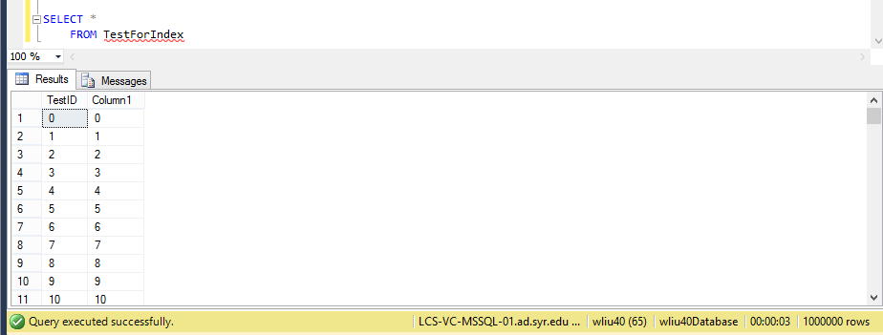

1. **Run the following selects from the table, take note of the time it took to select the data. Run each statement 10 times, Average out the rest of the runs (for both the CPU time and the overall times).**

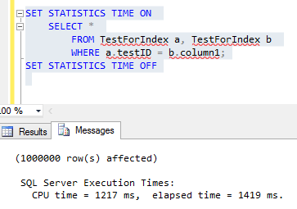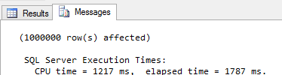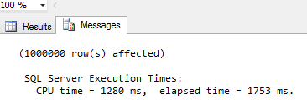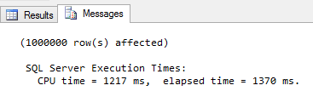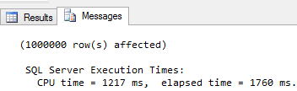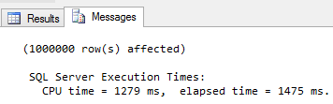

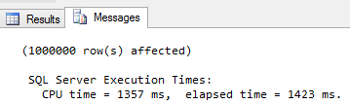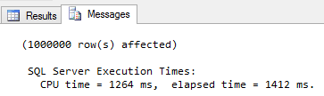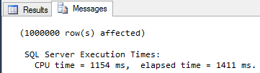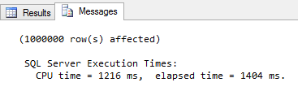

|  |  |  |
| --- | --- | --- |
| **Run without index** | | |
| # | CPU Time(ms) | Overall Time(ms) |
| 1 | 1217 | 1419 |
| 2 | 1217 | 1787 |
| 3 | 1280 | 1753 |
| 4 | 1217 | 1370 |
| 5 | 1217 | 1760 |
| 6 | 1279 | 1475 |
| 7 | 1357 | 1423 |
| 8 | 1264 | 1412 |
| 9 | 1154 | 1411 |
| 10 | 1216 | 1404 |
| Avg | 1241.8 | 1521.4 |

1. **Create an index on the column1 column.**

CREATE INDEX MyIndex ON TestForIndex(Column1);

1. **Run the selects again, following the same process as in #4.**

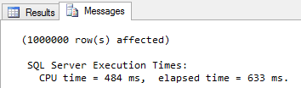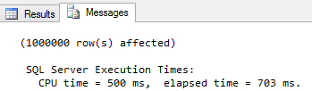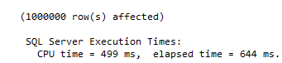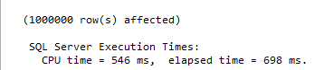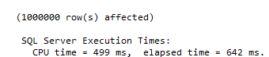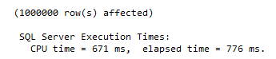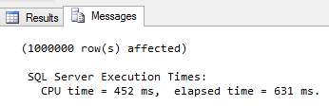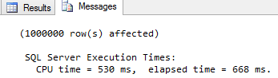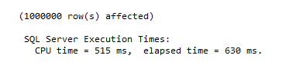17-21

|  |  |  |
| --- | --- | --- |
| **Run with index** | | |
|  | CPU Time(ms) | Overall Time(ms) |
| 1 | 484 | 633 |
| 2 | 500 | 703 |
| 3 | 499 | 644 |
| 4 | 546 | 698 |
| 5 | 499 | 642 |
| 6 | 671 | 776 |
| 7 | 452 | 631 |
| 8 | 530 | 668 |
| 9 | 515 | 630 |
| 10 | 453 | 611 |
| Avg | 514.9 | 663.6 |

1. **Compute the difference (percentage change and actual change) between the indexed and non-indexed runs. Make sure that the performance increased as expected.**

Conclusion:

The performance was improved obviously.

The absolute time was decreased by 726.9ms (CPU time) and 857.8ms (Overall time).

The percentage change was calculated by 729.9/1241.8 = 58.5% (CPU time) and 56.4% (Overall time).

1.